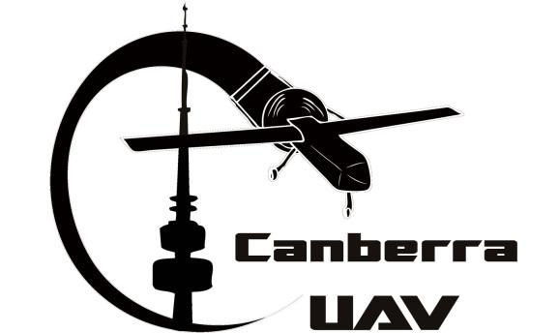

Deliverable 1 Report
  - UAV Challenge 2016 (Medical Express)

Summary
The CanberraUAV design approach is to use up to two VTOL UAVs. The Retrieval UAV will fly along the designated corridor then take a high resolution image above the given coordinates of Joe. Image analysis will then be used to determine both Joe’s location and the best landing site. The Support UAV (if required) will maintain an optimal position for relaying radio communication between the ground station and the lander.
Communications will be maintained via low bandwidth relayed telemetry radios, a higher bandwidth ethernet bridge, a 3G modem and a satellite modem. Experimental results in the lead up to Deliverable 2 may result in us reducing the number of communication links, and possibly avoiding the need for the Support UAV.
Testing thus far has concentrated on large petrol powered RC helicopters, but we are also developing an alternative hybrid VTOL UAVs that may be used if testing results are positive.

Project Status
The CanberraUAV team has been working hard towards our goal of a safe and reliable platform for collecting the sample bottle from Joe. Key achievements to date include:
- Successfully participated in the 2012 and 2014 UAV Outback Challenges; placing first in the Search and Rescue Challenge in both events.
- Extensively enhanced the APM autopilot for higher accuracy and reliability.
- Built and tested a custom ground control station using a network of several laptops.
- Refined the automated takeoff and landing system into the autopilot software.
- Autonomous flight of a UAV capable of vertical takeoff and landing (Helicopter).
- Investigation, development and testing of a variety of airframes capable of vertical takeoff and landing.

Flight testing has been performed in a variety of low and high wind conditions, in order to ensure the competition requirements can be met under the weather conditions specified in the UAV Challenge Rules.

Overall Design of the UAV System

High Level Overview
A diagram of the overall system is shown below in Diagram 1. A description of each of the major systems is given in the subsequent text in this section.
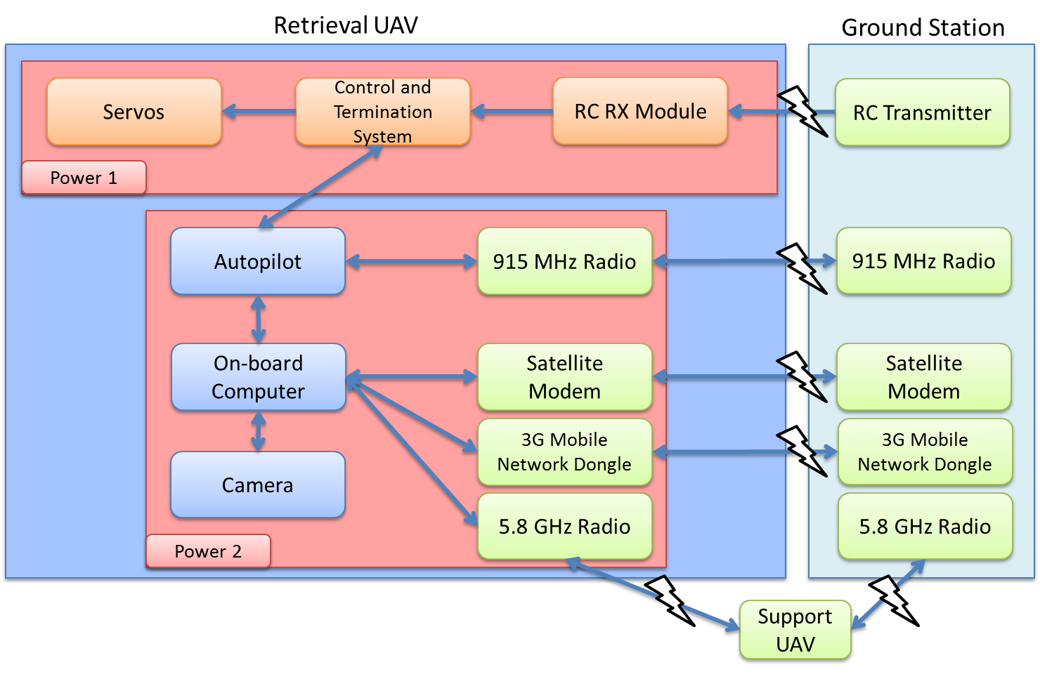
Diagram 1 – High Level System Overview
Airframe – At the time of writing, CanberraUAV is investigating 2 airframe options for both the Retrieval UAV and (if required) Support UAV. One is a large sized RC helicopter (700 size or similar) with a petrol engine. The other option is a fixed wing airframe fitted with a quadcopter capability to allow vertical takeoff and landing; outside of the takeoff and landing the airframe would transition to a traditional fixed wing airframe. Investigations are still ongoing as to which of these platforms is most suitable for the competition.
Autopilot – The autopilot will be based on the PX4 hardware platform, running the open source APM software. The primary connection to the Ground Control Station (GCS) will be via a low-bandwidth 915MHz telemetry and control radio link. A secondary connection via the on-board computer will allow for redundancy.
On-board computer – An ARM embedded computer will be used for image processing, automated Joe-finding, overall on-board mission control and airframe monitoring. It will be connected to the GCS via several radio links. It will be connected to the autopilot via a high speed serial link.
Joe detection and landing area camera – One machine vision camera (colour). It will be roll stabilised for a direct downward view. It will be connected to the on-board mission control computer via USB. The video will be analysed by the on board computer for selecting the frames of highest priority for transmission to the ground station.
Control and Termination System (C&TS) – This will be based on the Advanced Failsafe capabilities of the APM, which uses the IO microcontroller on the Pixhawk to ensure failsafe operation in the event of autopilot malfunction. When a failsafe criterion is satisfied, or when commanded, this will initiate the termination program with fixed servo settings as per the Rules. For helicopters this means closed throttle and ignition cut. For our hybrid UAV this means zero throttle on both sets of motors and full control surface deflections so as to enter a spin. It will also accept input from RC controller pilot when in visual range. The flight termination will take priority over RC control. The PX4 IO board will be separately powered from other systems.
915 MHz radio link – The telemetry and control link, over a 915-928 MHz ISM band telemetry radio, under the LIPD-2000 item 45 rules.
Satellite Modem – A datalink using a satellite constellation, to ensure coverage beyond line of sight when the Retrieval UAV is at low altitudes during takeoff and landing at Joe’s position. Depending on the exact model of modem used, the data stream will be routed via a Satellite Ground Station and terrestrial Internet or via a second satellite modem at the UAV Ground Station.
Mobile Network Modem – Standard commercial 3G/4G USB dongles will be used at both the Retrieval UAV and Ground Station, providing a connection via a commercial mobile network.
5.8 GHz Radio - A TDMA digital radio, using the 5.8GHz class license under LIPD-2000 item 45B rules. The radio will be running an IP link carrying digital video, MAVLink telemetry and mission control commands to and from the GCS. Due to the distances involved, a Support UAV (loitering near the Retrieval UAV) may be employed to route the data between the Retrieval UAV and Ground Station.
Ground Control Station – A custom GCS connected via both low and high-bandwidth links to the Retrieval UAV. The GCS provides NMEA GPS and video feeds to UAV Challenge organisers. It will perform control and monitoring of all aspects of mission. The GCS will report all waypoint crossings and other key mission parameters via audible announcements.
RC control – A standard “C-tick” 2.4GHz RC transmitter and receiver for visual range control.
IMPORTANT NOTE: At the time of writing, the exact communications method between the Retrieval UAV and ground station has not been comprehensively tested. For the purposes of this Deliverable, all potential methods under investigation have been listed in the above section. For the UAV Challenge, it is likely that a subset of these communications methods (that satisfy the UAV Challenge requirements) will be used.

Control and Termination System Design
The C&TS board is a standard part of the PX4/Pixhawk autopilot system, which CanberraUAV has been heavily involved in the development of over the last 3 years. The board will have custom firmware to provide support for all failsafe functionality of the UAV Challenge. The C&TS will be independently powered and will implement the primary FTS option using fixed maximum servo positions. The C&TS will monitor the autopilot, plus the RC receiver, and will be the sole controller of flight surface servos. Flight termination activation will proceed as per the following sections. Flight termination can be initiated by the GCS through controls to the autopilots. If the C&TS system fails, flight termination will be immediately initiated. Both the Retrieval UAV and Support UAV will have this fitted.

Geo-fence System
The autopilot will continually monitor mission boundary compliance via a GPS device. If the autopilot detects a mission boundary violation it will raise a signal on the C&TS, which will initiate flight termination. Mission boundary detection will be via the standard even-odd ray-casting rule for polygons. Mission boundary edges will be programmed into the autopilots non-volatile memory and checked during pre-flight preparation, as well as displayed on the ground station for operator monitoring. Audible warnings of approach of the geo-fence boundary will be used while under manual control during scrutineering.
Vertical boundary detection will be via barometric pressure. Compliance with AMSL pressure altitude limits will be performed by the autopilot and will trigger flight termination if breached.
The geofence will cover the base site, flight corridor and remote landing site fence
Both the Retrieval UAV and Support UAV will have this functionality fitted.

E-Stop
Both the Retrieval UAV and Support UAV will have an E-Stop device fitted (colours as per the UAV Challenge rules) in order to provide a visual confirmation that all power has been removed from the propulsion systems.

How the UAV(s) Will Be Employed to Complete the Mission
The following description covers all options being considered in terms of airframe and communications links.
The Retrieval UAV will takeoff vertically from the Base area. In the case of the “hybrid” airframe, it will transition for fixed wing flight once at a safe altitude. The Retrieval UAV will fly a pre-programmed set of waypoints through the Transit Corridor to the Remote Landing Station.
Once at the Remote Landing Station, the Retrieval UAV will loiter above the reported (approximate) location of Joe. A belly mounted camera with Joe-detection software will be used to pinpoint Joe’s location. From this a safe (30-80m away) landing waypoint will be picked and the Retrieval UAV will be commanded to land there. In the case of the “hybrid” airframe, it will transition to vertical flight for the landing.
Once landed, power will be removed from all propulsion systems and the Retrieval UAV will signal for Joe to load the blood sample.
Once Joe has signalled that the sample is loaded and is a safe distance away (via the arming switch and 1 minute wait), the Retrieval UAV will return to the Base area via the Transit corridor in the same way that it arrived there.
If a Support UAV used a communications relay for the 5.8 GHz radio link, it will follow the Retrieval UAV to the Remote Landing Area and remain loitering nearby (accounting for a safe separation between the two UAVs) whilst the Retrieval UAV picks up the blood sample. It will then follow the Retrieval UAV back to the Base area. For the purposes of flight separation the two UAVs will use offset waypoints whilst in the transit corridor and will have offset takeoff/landing locations at the Base area.

Risk Assessment
Failure Mode | Mitigation
Insurance | - Preliminary work will be carried out at our local model aircraft field under MAAA procedures with MAAA insurance, and the regular critique of fellow modellers. Extensive testing will be carried out at a private property near Canberra, within the one year span of appropriate insurance.
Airframe Operation | - Operation to be in line with MAAA procedures
Airframe Installation | - Competition aircraft and pilots to obtain MAAA heavy model certificate before flight of competition aircraft, if required.
Range Safety | - We will develop a range safety plan appropriate for each site. For the MAAA field we will use the MAAA Manual of Procedures. For our long range test site, we have developed appropriate range procedures, with a designated range safety officer.
Engine | - Starting and operation to be in line with MAAA procedures  - Engine starting procedure to follow general aviation practice.  - Stopping of engine to be by removing power to the ignition.  - While collecting the sample, any running petrol motors will be declutched and any external parts that could rotate will be locked. The red warning lights will remain lit if the locking system is not in place.
Fuel | - Petrol will be contained in a strong container to resist bursting on impact, containing only enough fuel to carry out the mission with adequate reserve. Appropriate safety procedures will be implemented for transport and storage.
Electrical power | - Separate battery packs for Primary control system, instrumentation and C&TS.  - Batteries for electronics systems to be NiMH or Lithium Iron Phosphate, not LiPo.  - LiPo batteries for vertical lift in the quadcopter version will be adequately padded and surrounded by a fireproof material.  - Batteries to be of capacity adequate for mission with reserve.
Connections, wiring and soldering | - To be carried out by experienced electronics technician with years of experience in model aircraft and marine electronics in the field.
Autopilot | - Loss of the heartbeat throughout software (written by a professional programmer) will signal failure to the C&TS.
Geofencing system failure | - Failure of the system running the geofencing program will alert the control and termination system by loss of the heartbeat.
Air traffic | - Radio watch will be held by pilot in charge during trials at the test range by an experienced aviation pilot.  - Flight altitude will not exceed 1500 ft AGL.  - Prior contact will be made with local gyrocopter pilots.
Fly away of UAV | - Extensive practice at test range to UAV Challenge rules (including geo-fencing), but with a soft termination to be carried out by the C&TS.  - Low energy VTOL takeoffs will be employed to enable long reaction time.
Rescue of lost UAV | - Procedures to be put in place by our experienced bushwalker prior to field testing.
Bugs in software | - Will use Hardware In Loop (HIL) and Software In The Loop (SITL) simulation testing to verify software and autopilot hardware, and reduce risk of software bugs.
Configuration management | - We are using best software industry practice for configuration management and software version control.

Risk Management

Safety First
The team will comply with CASR-101, but will additionally stress safety first, and will not fly unless we are sure it is safe to do so.

Liability and Insurance
Testing to this point has been at a MAAA insured site, staying within MAAA rules. We will obtain appropriate team insurance for both flight testing and competition flights.

Pilot Proficiency
Two team members hold MAAA (Model Aircraft Association Australia) gold-wings. The team has more than 50 years of aeromodelling experience between them.

Pre-flight tests
The team will use a combination of automated and manual checklists, physical inspection and testing to ensure all systems are operating correctly before flight. The GCS will display and report system status of all connected systems, and warn of any issues.

Radio Frequencies
All radio communication will be digital, including the video link. We currently expect to use:
- 915-928 MHz band for low-bandwidth digital telemetry and control link
- 2.4 GHz band for visual range RC control (ACCST or similar)
- 5.8 GHz band for high-bandwidth digital data link (Ubiquity TDMA)
- 850 MHz and 900 MHz 3G mobile network bands for high-bandwidth digital data link
- 1000-1500 MHz (L) bands for a low bandwidth satellite datalink used for telemetry. The exact frequencies will depend on the satellite network used.
The team is actively testing radio configurations and will adjust antenna and radio links based on test results and EIRP requirements.

RC Override
The RC override by the safety pilot will only be possible within visual range. Flight termination activation will take priority over RC override. Takeoff and landing will be under autopilot control, with the option of manual takeoff or landing at the discretion of the pilot. RC takeover and “stick mixing” will be used to allow instant override by the pilot without any intervention by the ground station operators.

Loss of data link
The UAV will monitor data link integrity of both the high and low-bandwidth links via MAVLink heartbeat messages sent from the GCS at a rate of 2Hz. On loss of data link for 10 seconds, the UAV will proceed to back to the Base area (via the transit corridor).If data link is not re-established after 2 minutes at the Base area and RC control is not possible by the pilot, a flight termination will be initiated. If RC control is possible the pilot will land the Retrieval UAV. Loss of GPS at the same time as data link loss will cause flight termination.

Engine Failure
The UAV will have electronic engine monitoring. In case of engine failure, the UAV will initiate a controlled glide towards the Base area, or autorotate to the ground as applicable for the airframe type.

Loss of GPS position
Loss of GPS position will switch the autopilot into a dead-reckoning mode which fuses sensor information from the compass, airspeed sensor and IMU to estimate position. In GPS failure mode the Retrieval UAV will circle, compensating for estimated wind, while maintaining current altitude for 30 seconds, and waiting for a GPS signal. If there is no signal after 30 seconds, then a termination will be carried out.

Autopilot lock-up
The autopilot will provide a 10 Hz heartbeat signal to the C&TS system. Lack of heartbeat for 0.4 seconds will cause the C&TS to initiate flight termination.

Failure of Ground Control Station
If the autopilot detects no communications heartbeat signal from the GCS for a period of 10 seconds then the loss of data link procedure will be initiated.

Additional systems
- Neither UAV will not use any pyrotechnic devices.

Battery Management
We will be using safer LiFePO₄ or NiMH cells for all on-board electronics. In the case of the “hybrid” airframe, LiPo batteries will be used for the vertical propulsion system. Best Practice techniques will be used for the safe usage and storage of the LiPo batteries.

http://www.canberrauav.org.au
http://plane.ardupilot.com
http://www.maaa.asn.au/

